Brief Curriculum Vitae
____________________________________________________________________________________
Stephan Schoeman
Soetkalmoes Consulting

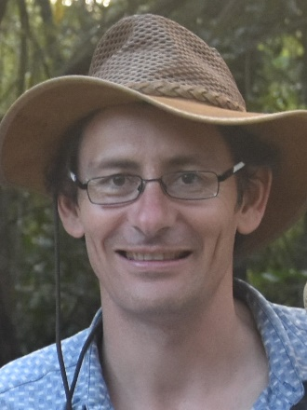

Stephan studied BSc(Agric) Horticulture and Soil Science at the university of Pretoria. As student, he was a skivvy with Omnia R&D. At the 1998 FERTASA Symposium his future path was decided: an MSc(Agric) in Citrus plant physiology as influenced by Open Hydroponics, which he through the University of Stellenbosch. This led to a managerial position on a future-focussed macadamia estate in Limpopo. He is an independent advisor since 2005 and has a keen interest in optimally managing tree crops through drip-fertigation. Stephan consults on nutrition and horticultural aspects in the subtropical fruit industry though Soetkalmoes Consultation, working off the cloud-based AgriWiz integrating platform. He lives in the magnificent Schoemanskloof, is married and has four daughters.

